We invite you to celebrate Phenology Week with your local community March 18-22 2024!
Use this media kit as a template to celebrate phenology with your community members. Feel free to use these images and text in their entirety or edit them to best fit your organization, Local Phenology Program, school, or club.
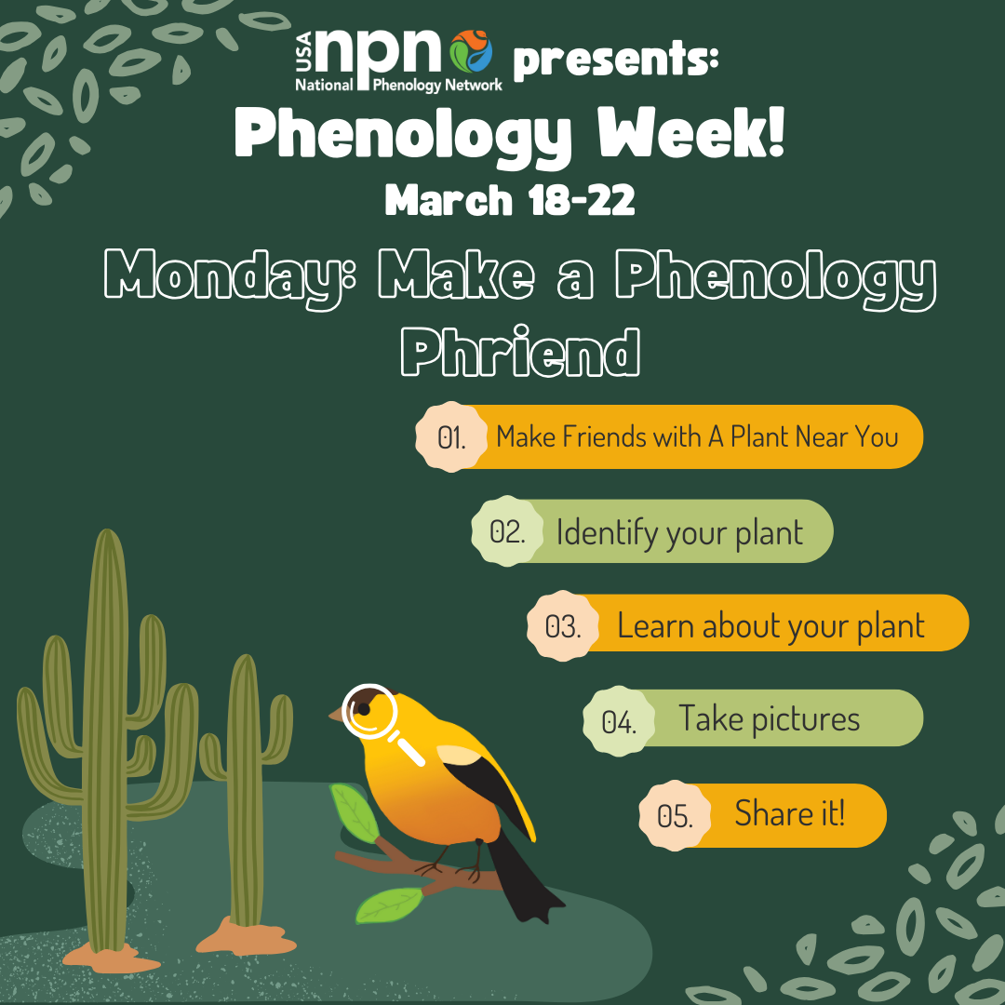
Monday: We’re celebrating phenology week with the USA National Phenology Network!

This Monday, we challenge you to make a #PhenologyPhriend. Find a plant that you see nearly every day and get to know it. Use the Seek app by iNaturalist or find a local gardening resource or plant identification guide to identify your plant, and learn about where it came from, the seasonal changes it experiences, and how it is adapted for your area. Take a picture of your plant and share what you learned with the #PhenologyWeek #MakeAPhenologyPhriend hashtags, and @usa_npn will share your phenology phriends at the end of the week!

If you would like to track the seasonal changes of your plant with #NaturesNotebook, create an account at naturesnotebook.org, add your site and plant, and learn how to collect phenology data that researchers can use to study seasonal patterns of plants and animals.

Alt-text for image: Phenology Week graphic for Monday, March 18, showing Spring the goldfinch with a magnifying glass looking at some saguaro cacti.

#UsaNpn #phenology #NaturesNotebook #volunteer #CitizenScience #Spring #Data

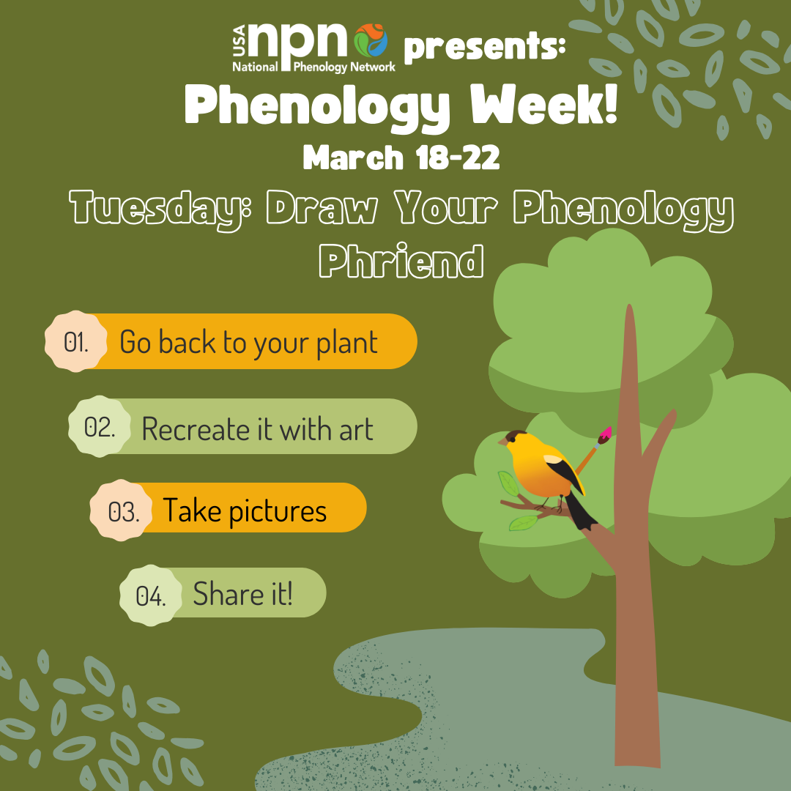
Tuesday: We’re celebrating phenology week with the USA National Phenology Network!

This Tuesday, we challenge you to practice some #NatureJournaling! Find your #PhenologyPhriend from Monday’s challenge and make an art piece with your Phriend as the model. When we stop to take the time and observe the plants around us, we learn to appreciate them more and notice the subtle ways that they show us who they are. You can portray your plant however you like (draw, paint, sculpt, etc.), just be creative! At the end of the week, @usa_npn will share your #PhenologyWeek posts and pieces.

If you would like to track the seasonal changes of your plant with #NaturesNotebook, create an account at naturesnotebook.org, add your site and plant, and learn how to collect phenology data that researchers can use to study seasonal patterns of plants and animals.

Alt-text for image: Phenology Week graphic for Tuesday, March 21, showing Spring the goldfinch in a tree with a paintbrush

#UsaNpn #phenology #NaturesNotebook #volunteer #CitizenScience #spring #data
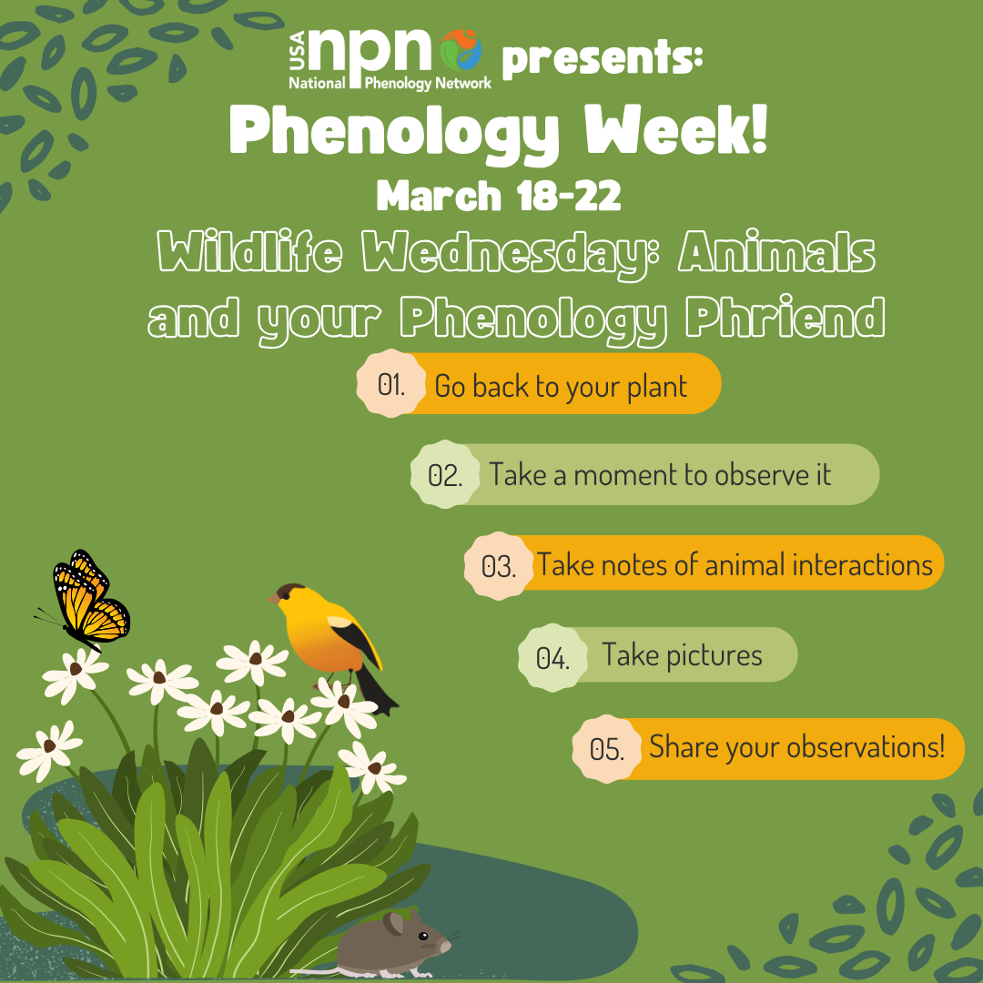
Wednesday: We’re celebrating phenology week with the USA National Phenology Network!

We are going to combine #PhenologyWeek and #WildlifeWednesday to learn more about observing animal phenology!

Check back in with your #PhenologyFhriend and see if any animals interact with it. These could be birds collecting branches for their nests, insects pollinating the flowers, spiders building their webs, or squirrels collecting acorns. Use the iNaturalist Seek app or local animal identification guides to identify which animal is visiting your plant so that you can learn more about it! Let us know what you observed with the #PhenologyWeek hashtag, and @usa_npn will share your observations at the end of the week!

Use the Nature’s Notebook species list at https://naturesnotebook.usanpn.org/npnapps/species t to see what animals in your area you can observe with Nature’s Notebook. If you already created a site and are monitoring the phenology of your new phenology phriend, see if you can add the animal that you discovered and collect observation data about its phenology.

Alt-text for image: Phenology Week graphic for Wednesday, March 20, showing Spring the goldfinch atop a patch of daisies with a monarch butterfly.

#UsaNpn #phenology #NaturesNotebook #volunteer #CitizenScience #spring #data

Thursday: We’re celebrating phenology week with the USA National Phenology Network!
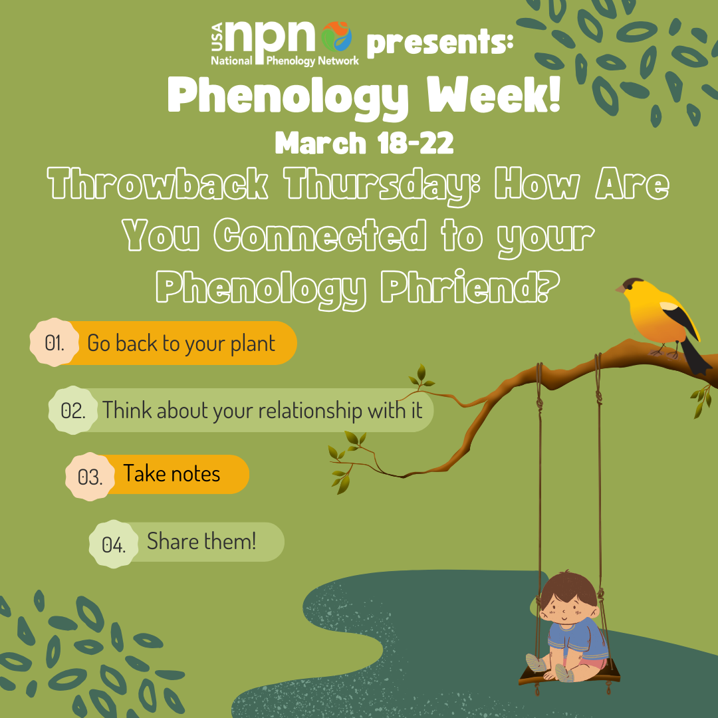
Today we are going to combine #ThrowbackThursday with your #PhenologyPhriend – does your phenology phriend hold special memories for you? Maybe it has historical or cultural significance to you, your family, and your community. If not, what is another plant that has meaning for you? Post a picture of your plant and tell us your story with the #PhenologyWeek hashtag, and @usa_npn will share your stories at the end of the week!

If you would like to track the seasonal changes of your plant with #NaturesNotebook, create an account at naturesnotebook.org, add your site and plant, and learn how to collect phenology data that researchers can use to study seasonal patterns of plants and animals.

Alt-text for image: Phenology Week graphic for Thursday, March 21, showing Spring the goldfinch on a branch holding a swing with a child sitting on it.

#UsaNpn #phenology #NaturesNotebook #volunteer #CitizenScience #spring #data

Friday: We’re celebrating phenology week with USA National Phenology Network!
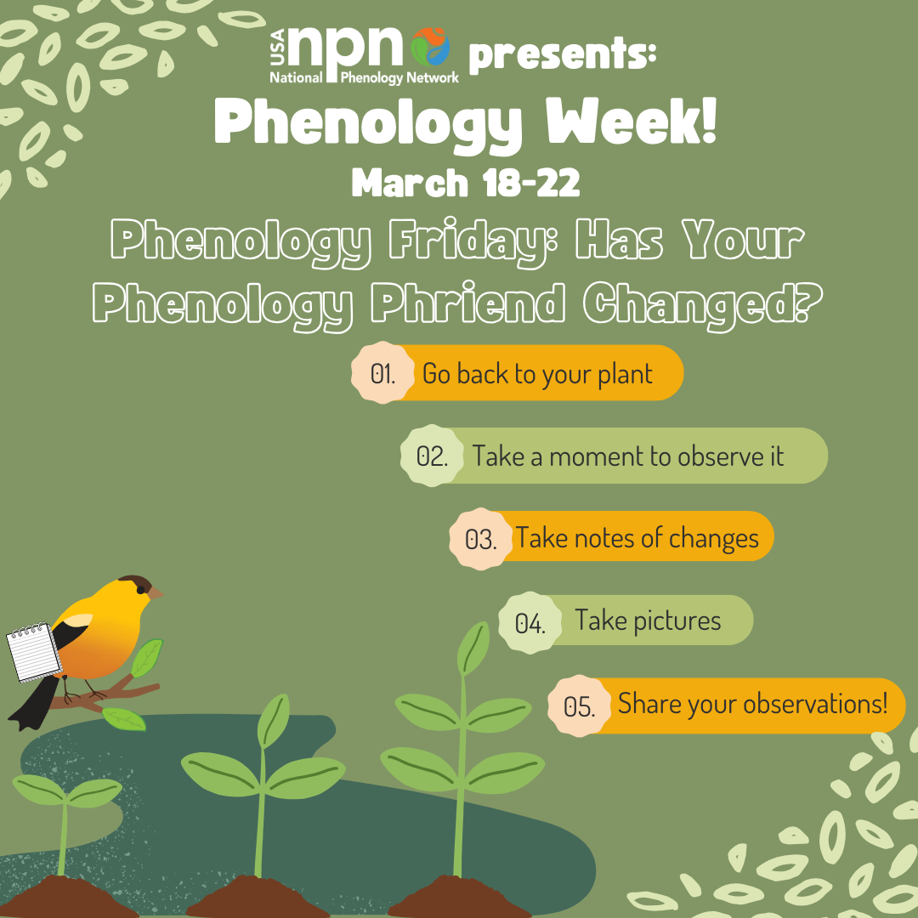
We are closing #PhenologyWeek with #PhenologyFriday – let’s end the week with one more visit to your #PhenologyPhriend – reflect on what you’ve learned about your phriend this week. Has your perception of your plant changed? What physical changes do you see in your plant? Make sure to check the Nature’s Notebook species list to see if your plant is there and make some observations! Send us your reflections and any photos of your phriend, and any phenology changes that you observed in your phriend during this week and @usa_npn will share your observations.

Thank you so much for celebrating Phenology Week with us, and we hope that you enjoy spending time with your new phenology phriend and learn more about its seasonal changes throughout the new year.

Alt-text for image: Phenology Week graphic for Friday, March 22, showing Spring the goldfinch with a notebook observing some growing seedlings.

#UsaNpn #phenology #NaturesNotebook #volunteer #CitizenScience #spring #data

USA NPN, Nature’s Notebook, and Phenology Week Logos

